Scholarship Impact Analysis in Tamil Nadu 2019
Prepared by Malini RoyChoudhury & Sambhav Agrawal
Executive Summary
Tamil Nadu has advanced in educational inclusion, yet 2019 Post-Matric Scholarship data reveal persistent gaps in distribution, gender equity, and school access. District-level disparities in beneficiary coverage, fund allocation, and representation highlight uneven program impact, particularly in underserved areas and among students outside current eligibility. Our analysis, using official data from data.gov.in, shows a disconnect between strong state-level intent and local implementation, driven by rigid, uniform criteria. Leveraging Microsoft Excel, Power Query, and Power BI, we identify that effective scholarship targeting demands district-specific strategies aligned with local enrollment patterns to ensure equitable access and maximize the scheme’s intended social impact.
Key Findings & Policy Recommendations
Visual 1: Gender Distribution in Higher Secondary School Enrollment Across Tamil Nadu District

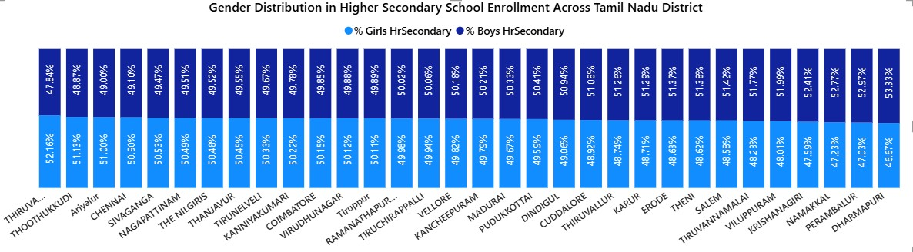

- Gender Imbalance in Dharmapuri district
The stacked column chart highlights a significant gender gap in Dharmapuri, where boys account for 53.33% of higher secondary enrollment compared to 46.67% girls. Despite an overall enrollment rate of 51.97%, the data suggests potential challenges in access or retention for female students in this district.
- Female Majority in Tiruvarur district
In contrast, Tiruvarur demonstrates a strong female lead, with 52.16% girls enrolled versus 47.84% boys. Although the district’s overall higher secondary enrollment stands at 48.06%, the gender distribution reflects positive strides in promoting girls' education.

Policy Recommendation: Implement targeted interventions in Dharmapuri including girls' education incentives, safety measures, and community awareness programs. Replicate Tiruvarur's successful practices through peer-learning exchanges and resource sharing between districts.

Visual 2: School Type Enrollment Distribution (Govt vs Private - Tamil Nadu District)
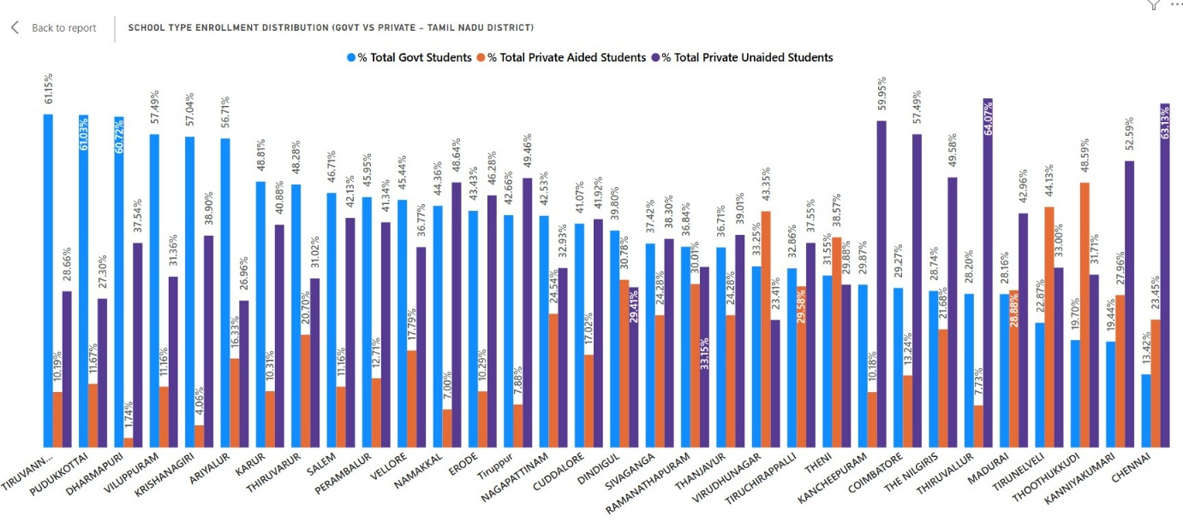
- Government School Dominance in Tiruvannamalai:
The clustered column chart highlights Tiruvannamalai, where 61.15% of students are enrolled in government schools. This reflects a strong dependence on public education infrastructure, possibly due to limited private school availability or greater community trust in government-run institutions.
- Private Unaided Preference in Chennai:
Chennai stands out with 63.13% of students enrolled in private unaided schools—the highest among all districts. This trend suggests a pronounced urban shift toward privately managed education, likely influenced by parental choice, infrastructure quality, and competitive academic offerings.
- Private Aided School Strength in Southern Districts:
Thoothukkudi (48.59%) and Tirunelveli (44.13%) lead in private aided school enrollment, indicating a robust presence of semi-private institutions supported by government grants. These districts exemplify a hybrid education model that blends public funding with private administration.
Policy Recommendation: Strengthen government schools in urban areas like Chennai through infrastructure upgrades and quality improvements. Expand the private-aided model proven successful in southern districts to create sustainable public-private education partnerships statewide.
Visuals 3: Boys’ Enrollment by School Type (Tamil Nadu Districts)
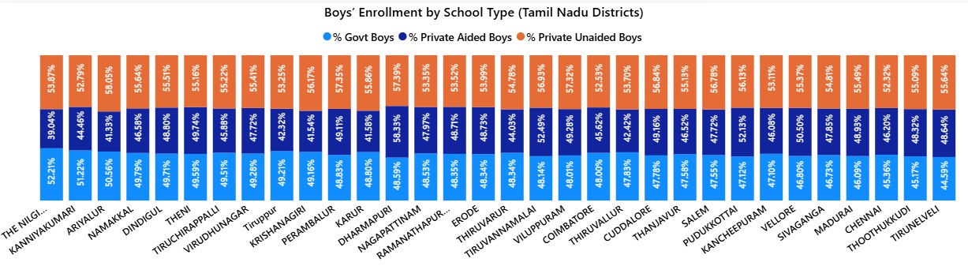
- The stacked column chart shows that Government school boys’ enrollment ranges mostly between 47-52%, while private unaided schools dominate in several districts with over 55% (e.g., Perambalur, Viluppuram, Dharmapuri).
- The Nilgiris and Kanniyakumari show higher government enrollment (~52%), whereas districts like Viluppuram and Perambalur lean heavily towards private unaided enrollment (~57%).
- Private aided schools have significant presence (40–50%), peaking in districts like Dindigul and Theni, indicating a balanced three-way split in some regions.
Policy Recommendation: Address the rural-urban divide by improving government school quality in districts with high private enrollment. Ensure scholarship schemes cover private school students to prevent exclusion based on institutional choice rather than financial need.
Visuals 4: Girls’ Enrollment by School Type (Tamil Nadu Districts)

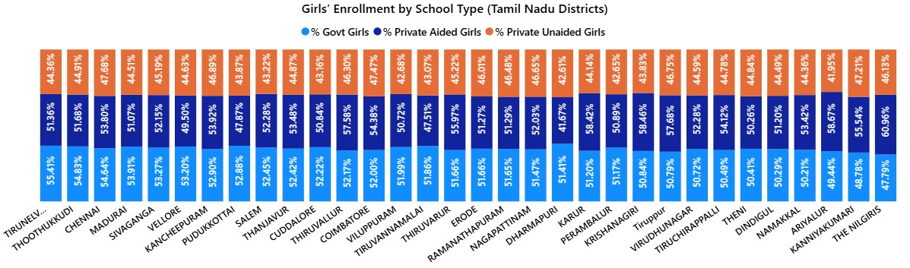
- The stacked column chart shows that Government schools show higher enrollment for girls across most districts (51–55%), peaking in Tirunelveli (55.41%) and Thoothukkudi (54.83%).
- Districts like Thiruvallur (57.58%) and Krishnagiri (58.46%) have a large share of girls in private aided schools, showing regional preference.
- Private unaided girls’ enrollment generally stays below 47%, unlike boys, suggesting stronger reliance on government and private aided schools for girls’ education.
Policy Recommendation: Leverage the success of government and private-aided schools in promoting girls' education. Investigate barriers preventing girls' enrollment in private unaided schools and ensure scholarship coverage extends across all school types.
Visuals 5: Post Matric Scholarship Scheme – Tamil Nadu (2019–20)
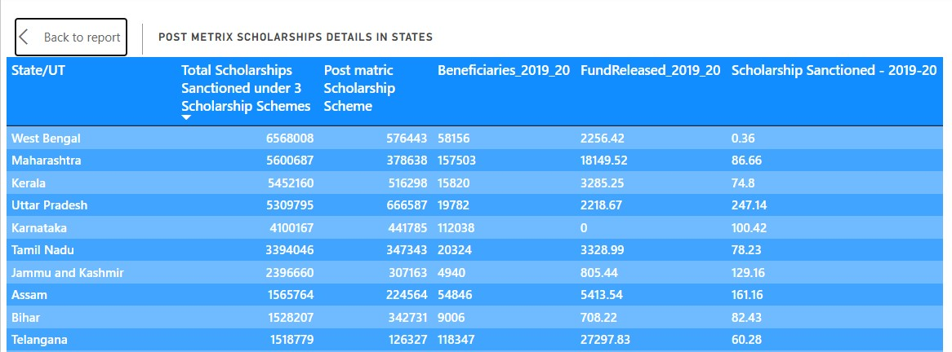

- The matrix table shows that Tamil Nadu sanctioned ₹78.23 lakhs under the Post Matric Scholarship Scheme in 2019 benefiting 20,324 students. This reflects a strong state level commitment to educational inclusion.
- The table also highlights interstate variation, with Tamil Nadu ranking among the top six performers in both fund disbursement and number of sanctioned scholarships, indicating efficient scheme execution.
- The scheme is designed to support students from disadvantaged backgrounds, enabling them to pursue higher education without financial barriers.
Policy Recommendation: Build on Tamil Nadu's strong performance by increasing scheme allocation and expanding eligibility criteria. Establish robust monitoring systems to ensure timely disbursement and create feedback mechanisms for continuous program improvement.

Visuals 6: District-wise Comparison of Scholarship Coverage
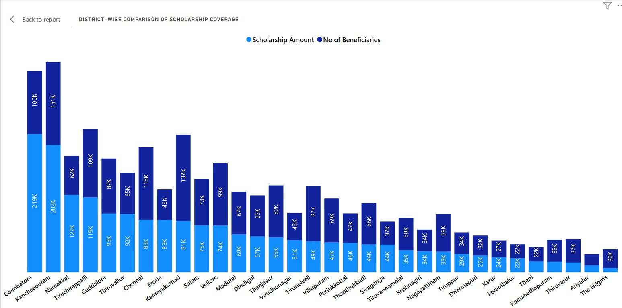

- Coimbatore and Kancheepuram Lead in Coverage:
The stacked column chart highlights Coimbatore and Kancheepuram as the top performing districts, with the highest number of beneficiaries and largest scholarship disbursement. Their strong performance reflects effective scheme execution and robust administrative outreach.
- Ariyalur and The Nilgiris Show Minimal Coverage:
Despite high student enrollment Ariyalur in government schools and The Nilgiris in private unaided schools both districts show notably lower scholarship coverage. This likely stems from eligibility constraints, particularly for students in private unaided institutions, which may fall outside the scope of certain government scholarship schemes despite substantial enrollment figures.
Policy Recommendation: Investigate and address systemic barriers in low-performing districts like Ariyalur and The Nilgiris. Modify eligibility criteria to include deserving students from all school types and strengthen district-level administrative capacity for better scheme implementation.
Overall Policy Recommendations
- School-Type Targeted Interventions: Strengthen boys’ enrollment in districts like Dharmapuri by recruiting qualified male teachers in semi-private schools. Offer fee subsidies for girls in private unaided schools and extra grants to private-aided schools with high female participation.
- Gender-Responsive Financial Support: In gender-gap districts (e.g., Dharmapuri), provide additional scholarships for girls plus free transport vouchers. In female-majority districts (e.g., Tiruvarur), offer vocational training scholarships for boys to improve retention.
- Enhanced Monitoring & Outreach: Use top-performing districts (Coimbatore, Kancheepuram) as training hubs for low-coverage areas. Run mobile scholarship camps in underserved districts like Ariyalur and implement real-time SMS/application tracking and district-level disbursement dashboards.

